ACCOMMODATION INFORMATION FOR INCOMING STUDENTS:

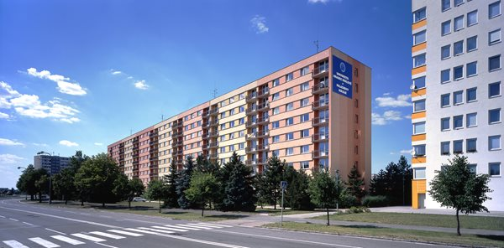

Your accommodation is booked at Palachova Halls of Residence/student dormitory of University of Hradec Kralove.

These Halls of Residence are situated in a southern part of the city Hradec Králové, in the Palachova street 1129, hence the name “Palachova dormitory“(„Palachova kolej” in Czech).

How to get to the Palachova Halls of Residence:
From Terminal HD or Main Train Station-take bus/trolleybus no.24 and get off at the bus stop Palachova, the journey takes about 20 minutes.

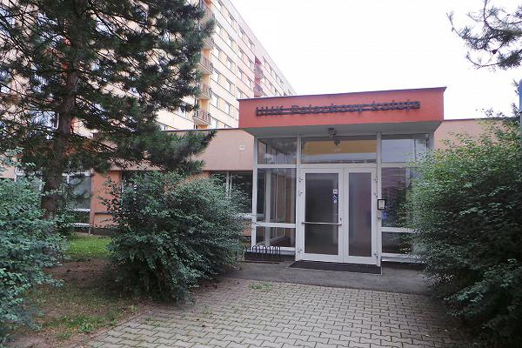

Check-In:
Immediately upon your arrival at the dormitory, you have to check in at the reception desk.
All arrangements concerning payments, housing contract and housing facilities
can be done at the Housing office–Reception desk.
It is open 24 hours, so you can arrive anytime of day.
However, we recommend that you arrive during working days and opening hours
( from 7 a.m. to 6 p.m.)
If you arrive at the weekend, you will be accommodated by the receptionist, and you should come to the housing office on the first week day in order to sign there dormitory accommodation contract and to pay for the tenancy/accommodation fee.

Housing contract:
You are obliged to sign a dormitory accommodation contract for your accommodation at the University Halls of Residence accommodation office.
In this contract, the exact period of your stay is stated.
(it relates to the period given in the housing application form, but is done on the basis of dates.
Please, be aware, you have to keep to this period, it is not possible to terminate your stay before the
contract expires, or/and from day to day.
If you would like to change the period of your stay (to shorten or to extend),
you must apply to change no later than 1 month before the contract expires and sign the Appendix attached to your contract!
If you do not change it, you will have to pay rent for the whole (original) housing period as stated in the contract, regardless of, when you really leave or would like to leave.

See the English translation of Dormitory Accommodation Contract valid at the Palachova Halls of Residence, as well the Halls of Residence and Accommodation Rules and Fire Regulation Rules. You will sign all these documents on your arrival.

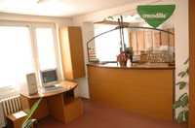
Key:
When checking in, you will be given the keys for your flat, room and entrance.
Be careful! If you lose your key or it gets stolen, you will have to pay a fee of 300CZK!

ACCOMMODATION FEE PAYMENT:
You are obliged to pay your accommodation fee for the whole period of your stay in advance.
The fee must be paid in CZK, only cash or credit card payment is accepted!
So please, ensure you have enough Czech crowns to pay on the site!

The cost of accommodation differs according to the flat size and block
(type of internet connection).

The price is usually around 3100CZK (approximately 120 EUR) per month.
Gas, electricity and water consumption are included in the fee.

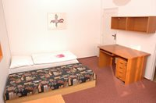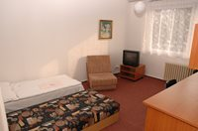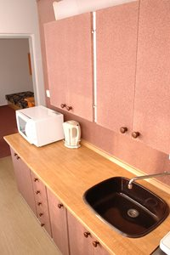

HOUSING AND FACILITIES:
Dormitory is not a club, that is why parties are not permitted at flats!
Please, respect other students and don’t play loud music and make noise
during quiet hours – from 10pm till 6am!
Keep your room clean and tidy!

You are strongly recommended to follow the Halls of Residence and Accommodation Rules.

Equipment
It is a block of flats, divided into blocks A-G. There are 7 floors in each block.
There are two-room flats.
Students usually share a room with one or two students,
according to the size of a flat, but maximum number of students in one flat is 4-6.

Kitchen and sanitary facilities are common for each flat.

For each student a desk and a bed with a pillow and a duvet are provided.
Bed linen can be obtained at a block caretaker and changed regularly.
There is a fridge with a freezer and an electric stove of two hotplates in the kitchen,
but it is not equipped with kitchenware.
Sometimes there may be something left from previous flat occupants,
but you’d better not rely on it.

You can borrow a blanket and a lamp for the whole semester from a block caretaker,
this service is for free.
If you need, you can also borrow vacuum cleaner for a few days,
it is for free as well.

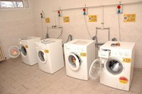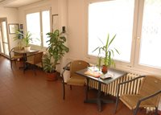

Facilities
At the dormitory grounds there is a playing field for volleyball, basketball or tennis.
Table-tennis room and piano room, and laundry are situated in the basement of the building.
An UHK club called LX can be found at the basement too.

You can access all the facilities by presenting your ISIC/Identity Card (you´ll be given after your arrival) at a reception desk.

Laundry is the only service paid for.
Using of washing mashine costs 20CZK per 3 hours plus 10CZK for each additional hour.
Using drying mashine costs 30CZK per 1 cycle.

Internet is accessible at the whole dormitory.
Blocks A and B are equipped with internet cables and the other blocks are covered by wi-fi network which enables to surf the internet free of charge. However, the connection speed is not guaranteed.
There is also a non-stop internet room at B building basement.

More information on:
https://www.uhk.cz/en-GB/UHK/Centralni-pracoviste/Vysokoskolske-koleje#UHK-Article

